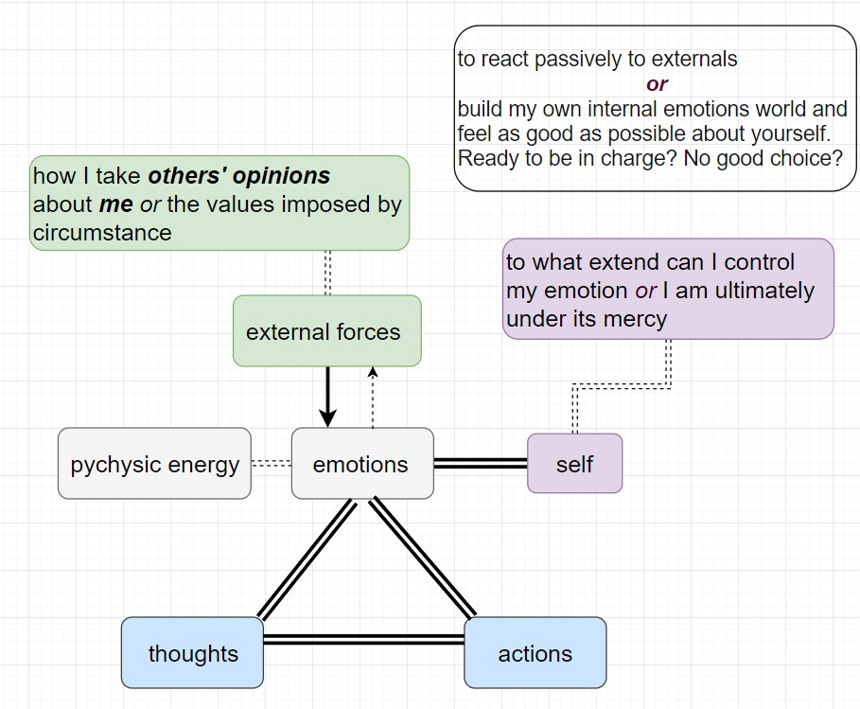

***Situation A (Workspace, my boos and me):***

Once the idea man (boss) came to me with an idea which is insane to me but terrific from his viewpoints (I tell this from his emotional make ups). I know quite well that I was not going to get promoted if piss him off by telling the truth. I knew he came to me not for my opinions but for reinforcement and to feel better about himself. I lied, every time it came up. I ***acted*** like I think so. I feel disgusting about it, always. But it is how I survive this world, **acting**. To pretend to be someone I am not, to tell what I do not think. And as time went by more faces got ready in my pocket.

I do not know where EI could swoop in for this case. How could I invest my attention another way so I could feel better about me? Glad to hear your thoughts.

***Situation B (college, interesting course but a boring instructor):***

I like to read philosophy and without thinking it twice I chose one philosophy related course in my freshman year, the tragic thing was the instructor turned out to be boring (I do not mean to be rude, but OH NO!!), and I could not drop the course (sad? But it was designed that way).

I did not want to be an audience in there, neither to fail it. What could I do? I cheated, about course assignments and the exams. Yeah, it was and is bad, I know. I did bad things, and the terrible thing is not I cheated but I do not feel much bad about it as I tell you now, I am impossible….

Would I take it another way if I knew what I know now about EI? I might try more to persuade myself to focus on the bright side about that course and engage my attention in that part. To make up a new story about how meaningful that course is, so I could feel better about attending that course.

How hard I would try? I do not know. I am not good at making up story to massage my repulsive emotions. Maybe this course can give me some hints or tricks (if you do not mind).

Is it what this course about?

To be in charge of one’s emotion world hence to have a better life experience since emotion is all one have?

To be able to tell myself whatever I want to know, to make up reasons so I can feel good about myself while pursuing something?

To turn pessimistic into optimal by shaping emotions?